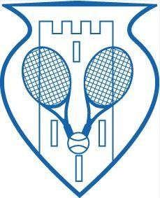
Swords Lawn Tennis Club Club Championships 2026 - Entry Form

Our Annual Club Championships Will Take Place From

Wednesday 29th July 2026 – Saturday 26th September 2026 Starting at 1PM

- Please tick the event(s) you wish to enter.
- The maximum number of events a competitor can enter is 3. • The cost of entry is €9 per event. If you enter 3 events, the cost is €25.
- All entries must be submitted on the Club Championships 2026 Entry Form.
- Completed entry forms must be left in the clubhouse or emailed to:
girvinstephen@gmail.com on/before Sunday 26th July 2026.
- Payment: Please give your entry fee to a committee member or by Revolut.

Finals Day Will Be Held On Saturday, 26th September 2026
(All Finalists Must Be Available To Play On Finals Day)

Name:

Phone Number: Email Address:

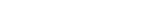
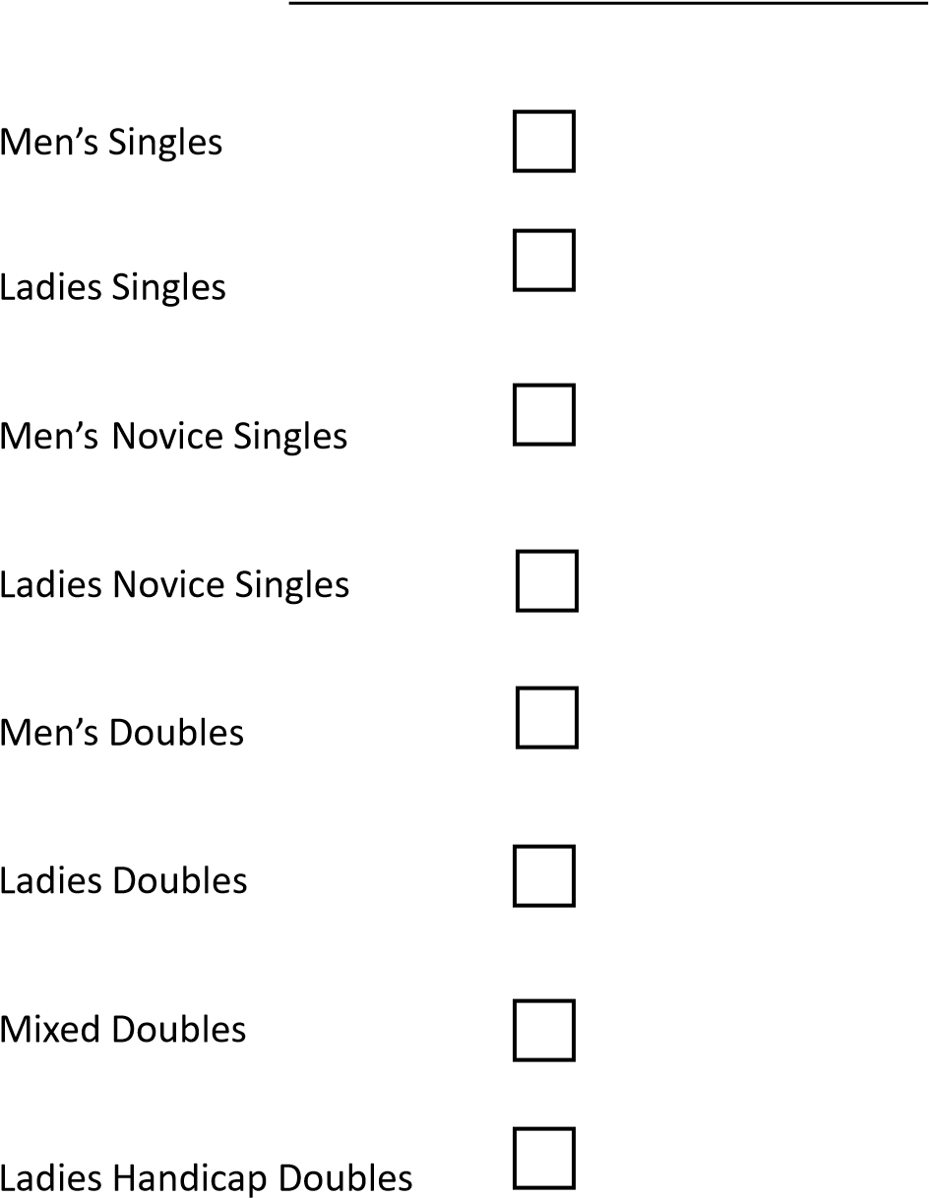Your partner will be assigned to you for this competition.

Partner’s Name _____________________________________________ Partner’s Name _____________________________________________
Partner’s Name _____________________________________________

Note: If you would like to enter a doubles event but do not have a partner, one will be assigned to you.

TOTAL FEE TO BE PAID: € _______________________

